Lab Report Walkthrough- 2 (2.5.5)

Title: Configure Initial Switch Settings

Objective
The objective of this lab was to:
- Verify the default configuration of Cisco switches
- Configure basic switch security settings
- Secure console and privileged EXEC access
- Configure a Message of the Day (MOTD) banner
- Encrypt plain-text passwords
- Save configuration files to NVRAM
- Verify proper configuration and security implementation

Part 1: Verify the Default Switch Configuration
In Part 1, the default configuration of switch S1 was examined.
Step 1: Place Devices
- Placed two Cisco 2960 switches: S1 and S2
- Placed two PCs: PC-1 and PC-2

Step 2: Connect the Device
- Connected S1 Fa0/1 to S2 Fa0/1 using a Copper Crossover cable
- Connected PC1 FastEthernet0 to S1 Fa0/6 using a Copper Straight-Through cable
- Connected PC2 FastEthernet0 to S2 Fa0/18 using a Copper Straight-Through cable
After connecting:
All devices were powered on
• Waited for the link lights to turn green
• Verified that all physical connections were correct
• Confirmed that the switches and PCs were properly connected according to the topology
This completed the physical topology setup.
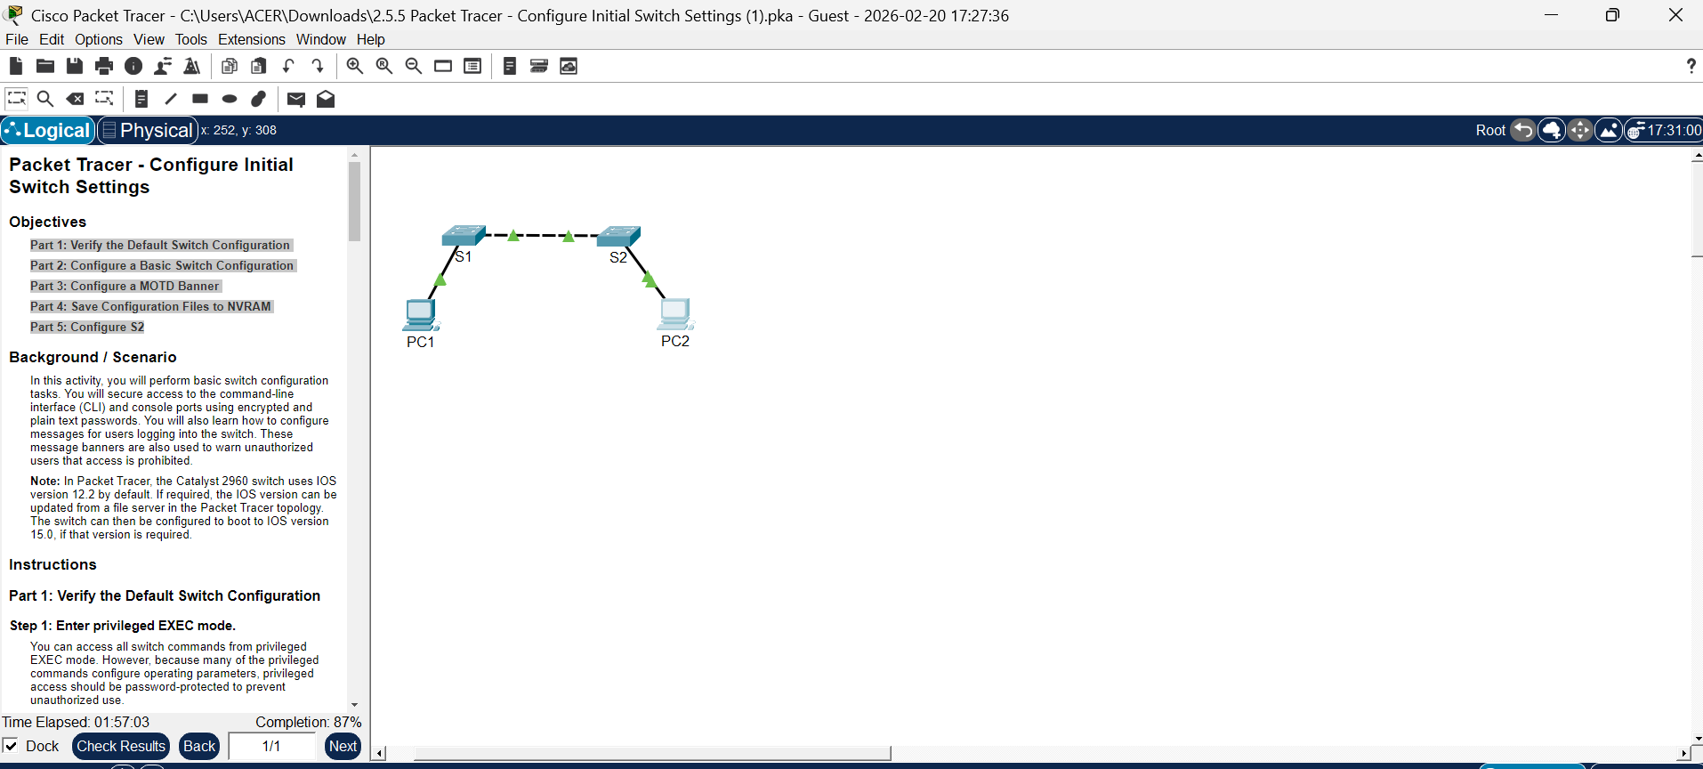
Step 3: Access Privileged EXEC Mode
- Clicked on S1
- Opened the CLI tab
- Entered privileged mode using:
Switch> enable
Switch#
Note: - The # symbol confirmed that privileged EXEC mode was active.

Step 4: Examine Running Configuration
- Command used:
show running-config
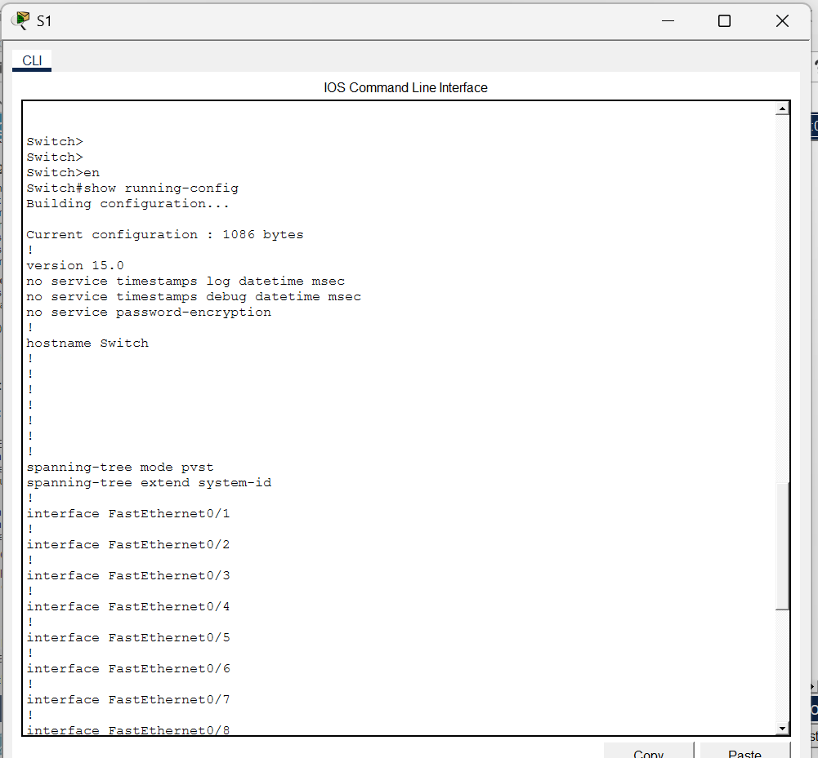
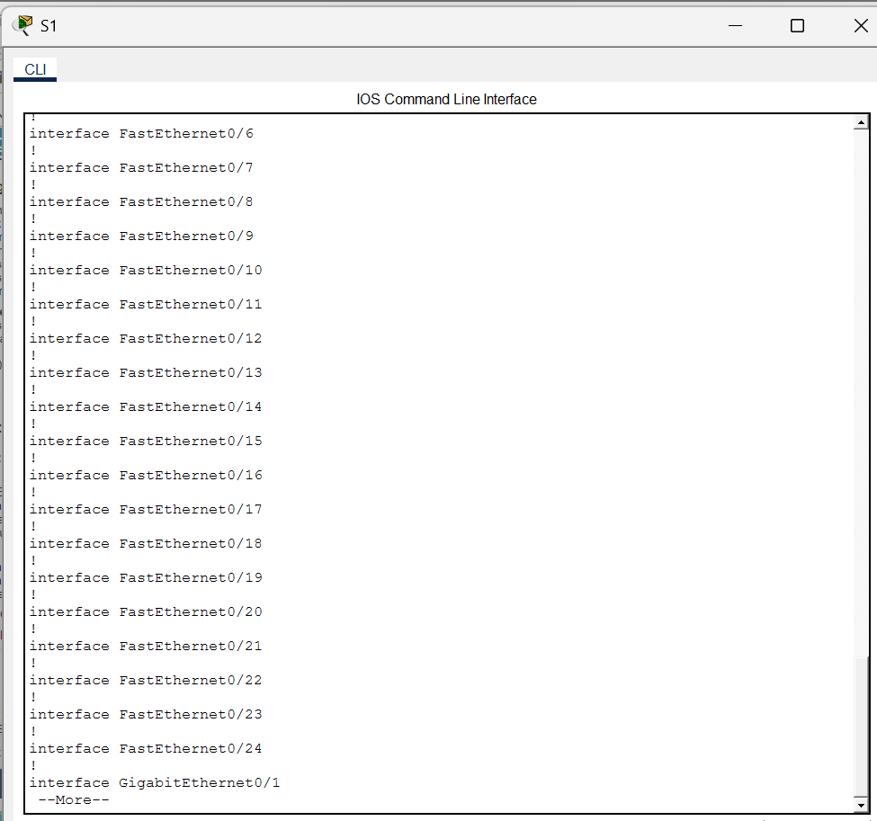
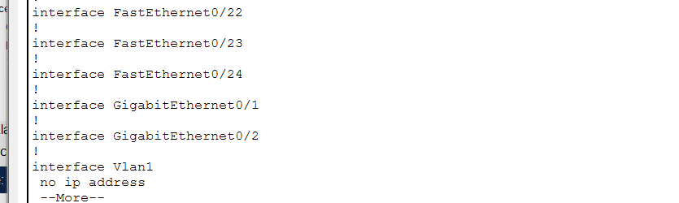

Observations:
- The switch contained 24 FastEthernet interfaces (Fa0/1 – Fa0/24)
- The switch contained 2 GigabitEthernet interfaces (Gi0/1 – Gi0/2)
- The VTY line range was 0–4
- The command to display NVRAM contents is:
show startup-config
- The message “startup-config is not present” appeared because the configuration had not yet been saved to NVRAM.
This completed the verification of the default switch configuration.

Reflection Questions: -
a) How many Fast Ethernet interfaces?
Usually we see: -
- interface FastEthernet0/1
- interface FastEthernet0/2
Most switches (2960) have:
- 24 FastEthernet ports (Fa0/1 – Fa0/24)
b) How many Gigabit Ethernet interfaces?
There are usually 2 Gigabit Ethernet interfaces: -
- interface GigabitEthernet0/1
- interface GigabitEthernet0/2
c) What is the range of vty lines?
The range of vty lines is 0 to 4, i.e., line vty 0 4.
d) Command to see startup configuration (NVRAM)?
The command is: show startup-config
e) Why does it say "startup-config is not present"?
It says startup-config is not present because: -
- We have not saved the configuration yet.
- The switch is still using the default configuration.
- Nothing is saved in NVRAM.

Part 2: Create a Basic Switch Configuration
In Part 2, basic security settings were configured on S1.
Step 1: Configuration of S1
- Entered global configuration mode: configure terminal (Conf t)
- Hostname set to SnehaS1
The device name changed from Switch to SnehaS1.
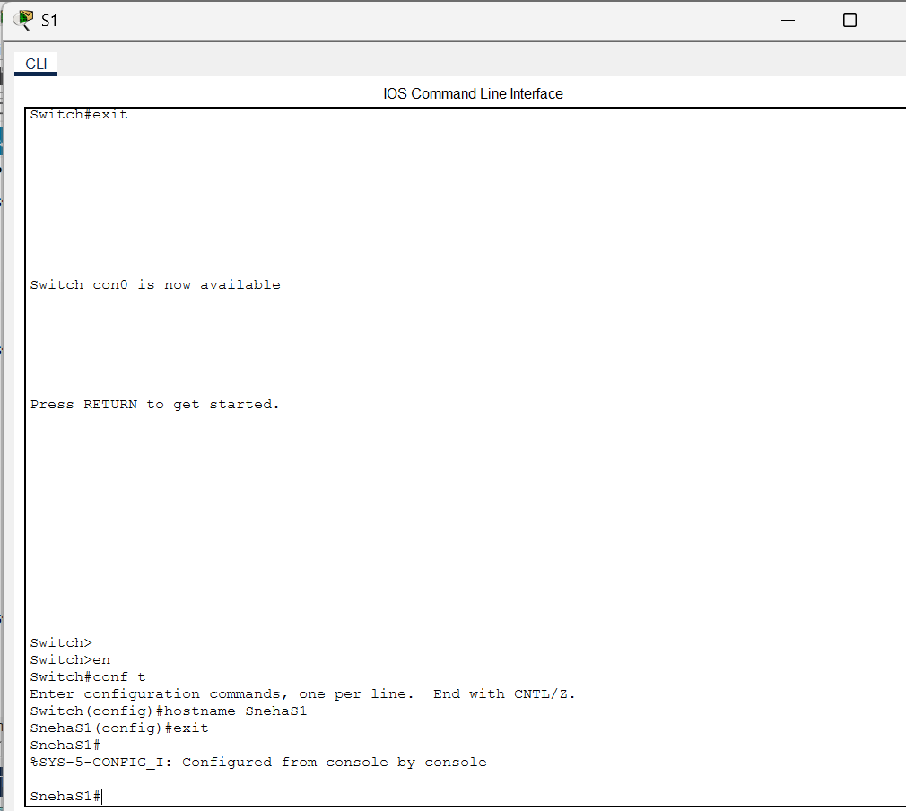

Step 2: Secure Console Access
- Console password was configured as follows:
line console 0
password letmein
login
exit
The login command was required to enable password checking.
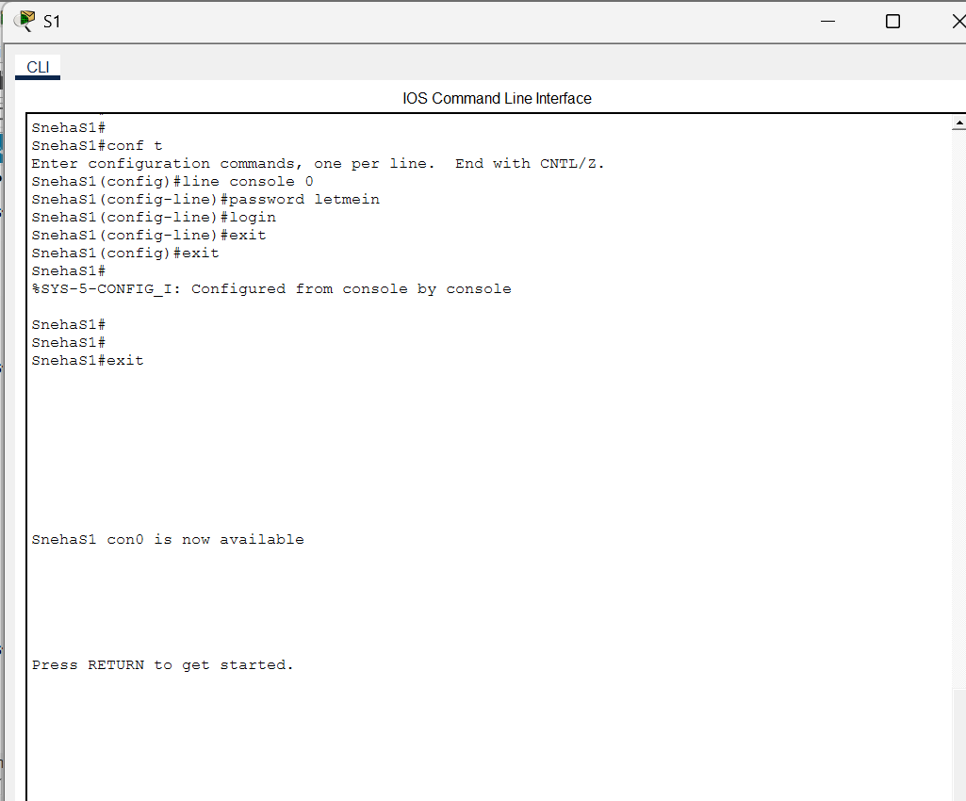

Step 3: Secure Privileged EXEC Mode
- Configured enable password: enable password c1$c0
- Configured encrypted enable secret: enable secret itsasecret
The enable secret password is automatically encrypted and overrides the enable password.
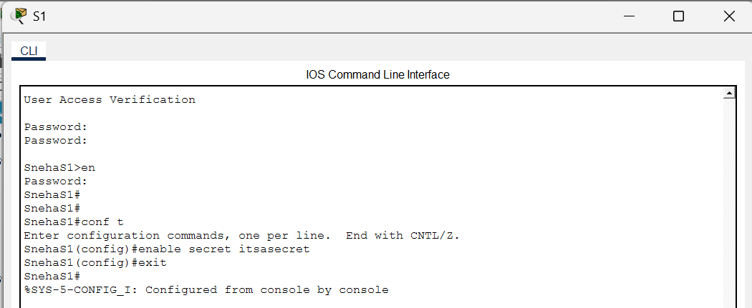

Step 4: Encrypt All Plain-Text Passwords
- To secure all visible passwords: service password-encryption
This encrypted the console and enabled passwords in the configuration file.
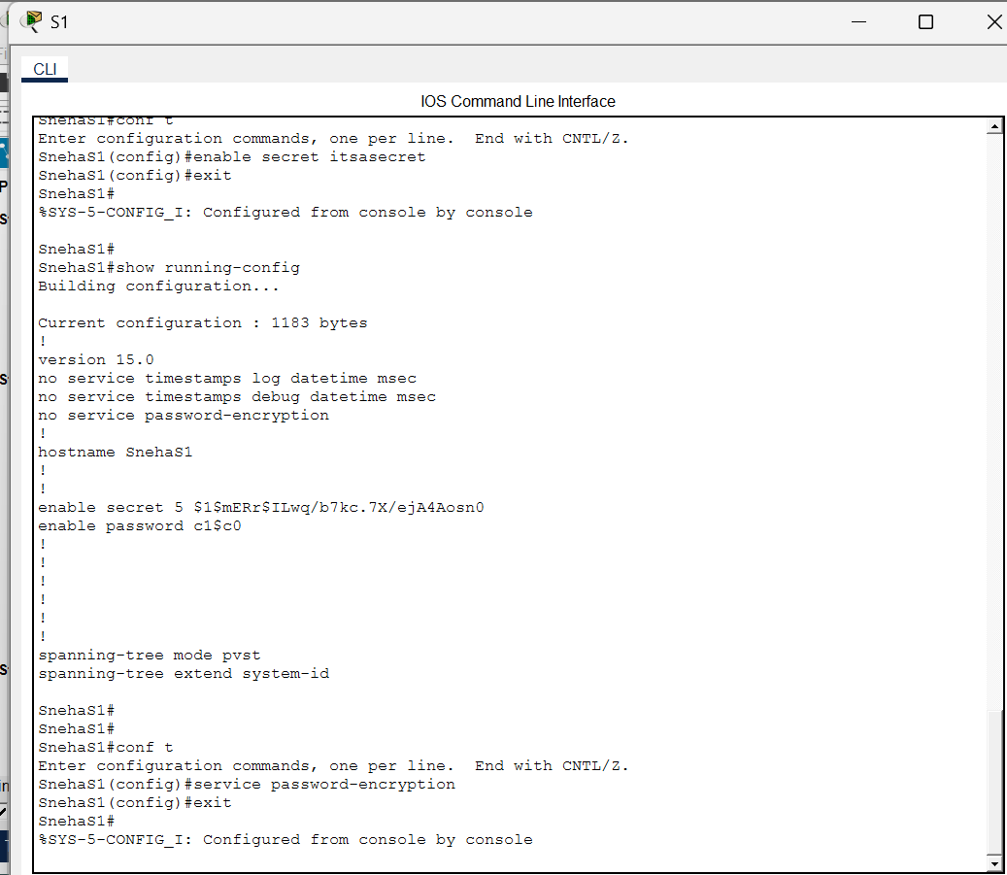

Reflection Questions: -
Question 1: Why is the login command required?
  - The login command is required to enable password checking on the console line. If the login command is not configured, the switch will not prompt the user for a password even if a password is set.
  - In simple words: Without a login, the password will not work.

Question 2: What is displayed for the enable secret password?
  - After typing: show running-config
  - The enable secret password is displayed in encrypted form, something like: enable secret 5 $1$xyz$abcdefg....
  - It does not appear in plain text.
Question 3: Why is the enable secret password displayed differently from what we configured?
  - The enable secret password is automatically encrypted by the switch for security purposes. This makes it more secure than the enable password, which is stored in plain text (unless encryption is enabled).

Question 4: If you configure any more passwords after using service password-encryption, will they appear in plain text or encrypted form? Explain.
  - After enabling the service password-encryption command, all new passwords configured on the switch will appear in encrypted form in the running configuration file. This improves security by preventing passwords from being viewed in plain text.

Part 3: Configure a Message of the Day (MOTD) Banner
A security warning banner was configured:
banner motd "This is a secure system. Authorized Access Only!"
Banner Behavior
- The banner is displayed before the login prompt.
- It warns unauthorized users that access is restricted.
- It provides legal and security notice.
This improves overall network security awareness.
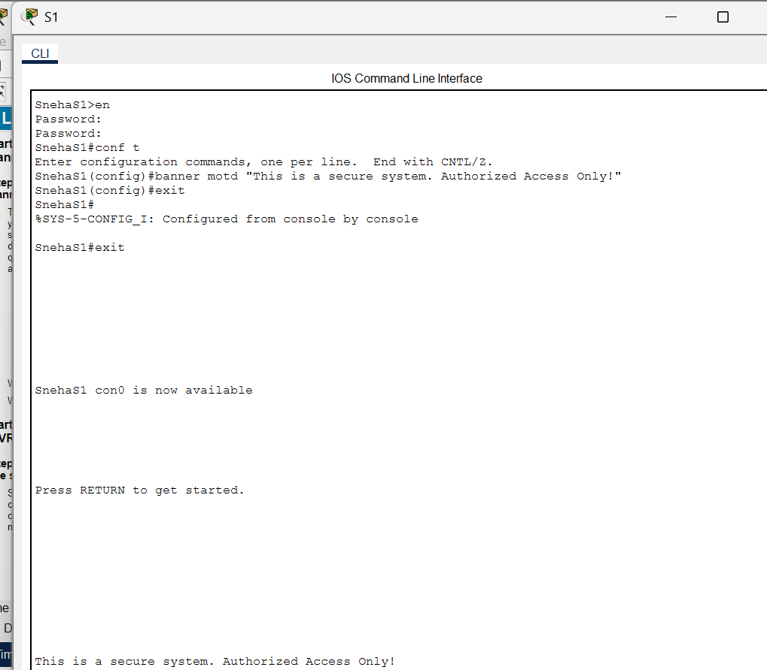

Reflection Questions: -
- When will this banner be displayed?
  - The MOTD banner is displayed whenever someone attempts to access the switch through the console, Telnet, or SSH before the login prompt appears.

- Why should every switch have a MOTD banner?
  - Every switch should have a MOTD banner to:
- Warn unauthorized users that access is restricted
- Display legal notice or security warning
- Inform users that the system is monitored
- Improve network security awareness

Part 4: Save and Verify Configuration Files to NVRAM
After completing the configuration, the settings were saved permanently.
Step 1: Save Running Configuration
copy running-config startup-config
- Shortcut command: copy run start
- The system displayed:
Building configuration...
[OK]

Step 2: Verify Saved Configuration
show startup-config
All configured changes were successfully stored in NVRAM.
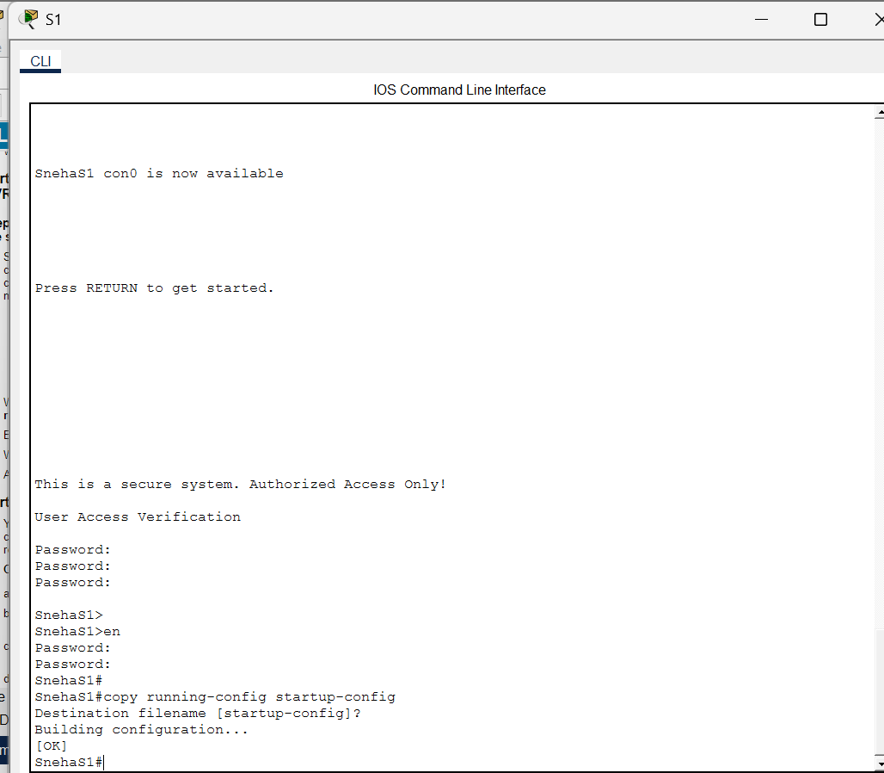

Reflection Questions: -

1. What is the shortest abbreviated version of: copy running-config startup-config?
copy run start
Cisco allows command abbreviations.
- Which command will display the contents of NVRAM?
show startup-config
This shows the saved configuration stored in NVRAM.
- Are all the changes recorded in the file?
Yes, all the configuration changes that were saved using the copy running-config startup-config command are recorded in the startup configuration file in NVRAM.

Part 5: Configure S2
The same configuration process was applied to S2.
Step 1: Configure Hostname
configure terminal
hostname SnehaS2

Step 2: Secure Console Access
line console 0
password letmein
login
exit

Step 3: Configure Privileged Mode Security
Enable password c1$c0
enable secret itsasecret

Step 4: Configure MOTD Banner
banner motd "Authorized Access Only!"

Step 5: Encrypt Passwords
service password-encryption

Step 6: Save Configuration
copy running-config startup-config
Configuration was successfully saved to NVRAM.
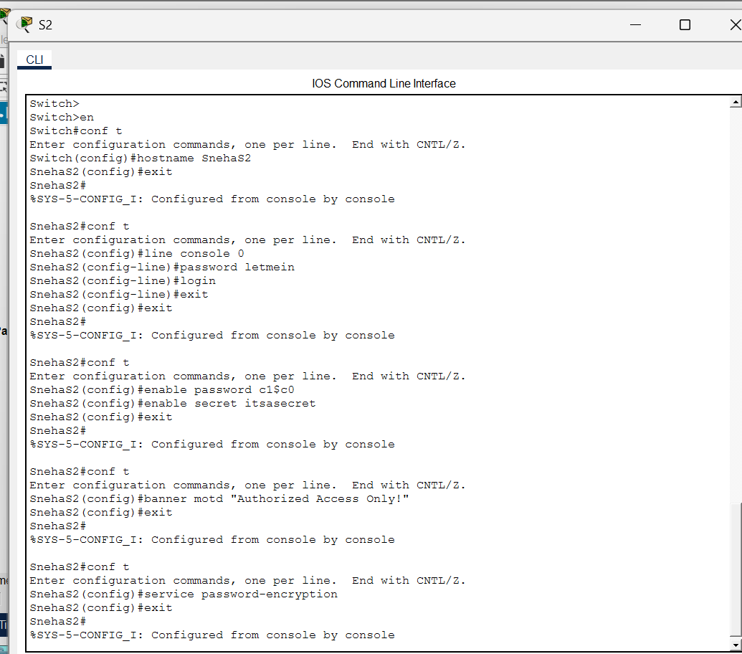

Final Verification
The following command was used on both switches:
show running-config
Verification confirmed:
- Hostnames correctly configured
- Console passwords encrypted
- Enable secret encryption
- MOTD banner present
- Configuration saved to startup-config
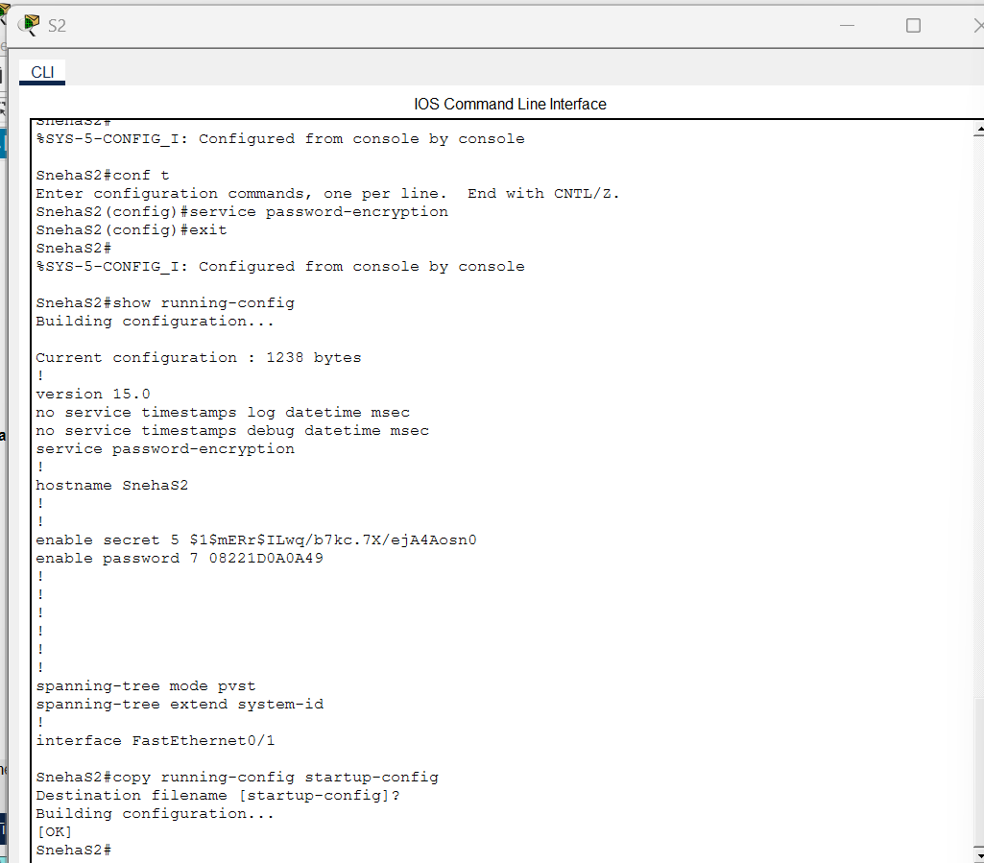

Conclusion
The lab objectives were successfully achieved. Both switches were properly configured with secure access settings and encrypted passwords.
This lab provided a practical understanding of:
- Switch default configuration verification
- Console and privileged mode security
- Password encryption
- MOTD banner implementation
- Saving configuration files to NVRAM
All configurations were verified and saved successfully. The lab was completed successfully.

Reflection Questions: -
1. Why is the enable secret password more secure than the enable password?
The enable secret password is automatically encrypted and cannot be viewed in plain text, making it more secure than the enable password.
2. Why is it important to save the configuration to NVRAM?
Saving the configuration ensures that all settings remain intact after the switch is rebooted or powered off.

